**ACTIVITY : PROCEDURE FOR USING TOWER LADDER**

________________________________________________________________________

* Objective : - Safe procedure for using tower ladder
* Scope : - Blast furnace 1 & 2
* Ref : - Tower ladder Instruction manual
* Responsibility : - Engineer In charge and workmen at the job, Contractors

**PPE –s to be used:**

* Safety Helmet, Safety shoes, hand gloves & safety belt, dust mask, safety goggle

**Aspect – Impact :**

Scrap generation Resource Depletion

**Hazards identified**

**Physical hazards:**

Dust inhalation, congestion,

**Mechanical Hazard**:

* 1. Fall of person from height.- fall of person from height below 5 mtrs and fall of person from height above 5 mtrs to 20 mtrs.
  2. Fall of material, tools and tackles, etc.
  3. Trapping of a person’s hand/fingers in between sliding ladder
  4. Overturning of ladder due to unevenness of ground, excessive pulling, trying to reach to a location
  5. Failure of ladder members due to overloading, failure of bolts / sections
  6. Failure of rope
  7. Uncontrolled movement of ladder in slope
  8. Injury to near by persons while taking turn
  9. Hit by road traffic / plant moving machinery while shifting

**Human Behavior aspect of operators**:

Operator nature, alcoholism, casual approach, horse play, use of mobile at workplace, back pain & non usage of PPE?s

**Chemical hazard:** Co gas poisoning , fire

Electrical Hazard:

Electric shock from overhead power lines

Shock due to welding, electrical cable, light fitting

* 1. This ladder conducts electricity - keep away from live wires. Failure to do so will result in electric shock to the user.

* 1. Since the ladder is mounted on frames having wheels, adequate care should be taken before the ladder is towed. The user should ensure that the ladder must securely be held on to the support arm in the horizontal position to avoid damage during transit.

* 1. Adequate care should be taken while negotiating curves as the frame wheels do not swivel—in the case of fixed wheels only.

* 1. Ladders that are mounted on trolleys should not be towed beyond a speed of 1 KMPH. Adequate care should be taken in transit to avoid accidents and damage to the ladder particularly on slopes with uphill/downhill gradient as the trolley wheels are not equipped with any braking mechanism.

* 1. Do not tow/carry the ladder when it is in the vertical or in extended position. The ladder in horizontal position should be securely tied with the support arm during transit.

* 1. Ensure proper cleaning & lubrication of all moving parts frequently.

* 1. To ensure total safety, periodic checks of the proper functioning of the wire rope & rope clamps and safety locks is a must before use of the Tower Ladder.

* 1. Ensure that the base frame is properly levelled before the ladder is turned to vertical position and further extended.

* 1. After ensuring that the ladder base frame is properly positioned on level ground, release the ladder from the support arm before raising the ladder to vertical position.

* 1. For positioning the base frame properly on unleveled grounds and loose soil use of wooden blocks under the base frame is recommended. Trolley mounted on wheels provided with four out riggers having screw jacks must be swung out & positioned diagonally to the base frame on the screw supports to ensure proper stability of the base frame. Care must be taken to ensure that the wheels are properly supported on the ground.

* 1. Do not climb onto the ladder without positioning the out riggers & ensuring stability of the base frame on the ground.

* 1. Do not attempt to operate the winch (see Fig 3c) to raise the ladder without releasing the ladder from the support arm. This will cause permanent damage to the ladder.

* 1. While raising the ladder it must be ensured that no one stands below the ladder as it is dangerous and can cause injury in case the wire rope or links fail

* 1. Before raising the ladder to the vertical position, the two spring lock pins (see Fig 3a) should be drawn back and engage into the rungs of the base section.

* 1. To raise & extend the platform height, operate the winch mounted on the base section (see Fig 3b) ladder clockwise. After extending the platform to the required height, it must be ensured that locks on to the fly section are securely locked on the base section rungs to ensure safety (see Fig 1a).

* 1. Do not operate the winch with person standing on the platform as the operation becomes difficult to crank, and it will not be safe for the operator, in case of failure of wire rope joints.

* 1. This ladder is designed for fail-safe use up to a load not exceeding 150Kgs (i.e.

Combined load of the one user & material)

* 1. In case of ladders mounted on vehicles, adequate care should be administrated to keep away from Over Head live wires or in the areas where tree branches or any other objects obstruct the way. Do not attempt to transport the ladder in the vertical position even for a short distance.

* 1. Ensure that the wire ropes are not kinked and frayed and all the mounting parts of the wire rope are in good condition. The wire rope should be periodically applied with anti rust compound

* 1. This ladder is equipped with a positive mechanical stopper at the maximum extended position of fly section. Trying to extend the ladder beyond the maximum height will cause permanent damage to the ladder.

* 1. Clear indications on the winch are provided for the direction of rotation of the hand lever to the winch for raising or lowering the ladder.

* 1. Unlock the two spring loaded lock pins on the ladder (see Fig 3a) and rotate the hand lever on winch (see Fig 3c) in anti-clockwise direction to bring the ladder to horizontal position. It is to be ensured that the ladder completely rests on the support arm and the wire rope on the winch drum is not under load or tension.

* 1. After the ladder is tilted to the vertical position, ensure that the ladder is properly butt to the support structure and locked to ensure that there will not be any stress on the ladder during operation which can cause permanent damage to the ladder.

* 1. The base frame is provided with necessary mounting holes in case of truck mounted tower ladders and the user is advised to ensure firm mounting of the base frame on the vehicle chassis before use.

* 1. The enclosed drawings clearly specify the technical specifications showing the description of the parts of the ladder.

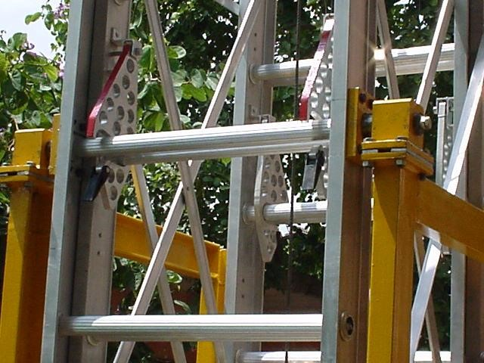

1

**a**

**b**

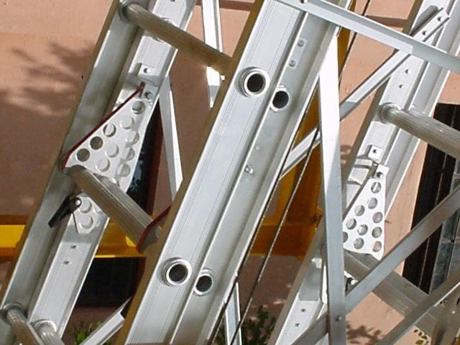

2

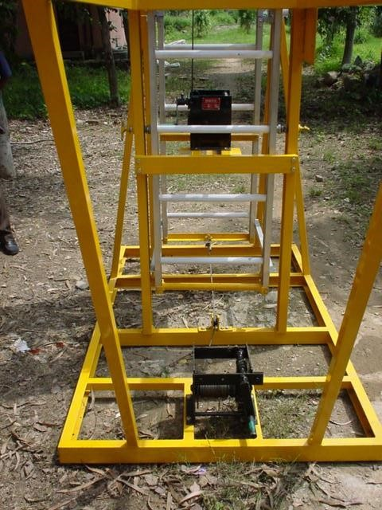

3

**a**

**a**

**b**

**c**

DO :

1. Make sure that extension ladder is

* Free of damage to rungs, side rails and hardware.
* Set up so that the base is level and bottom can’t slip
* Properly secured at top.
* Free of damage to the body like cracks
* Set up with the leg fully extended and locked

DO NOT:

1. Raise or lower the fly section of the ladder with the user standing on it.
2. Use the ladder without ensuring that the locks (4 nos) are properly engaged onto the base section rungs.
3. Extend/Retract the fly section when the ladder is in the horizontal position.
4. Tilt the ladder in the extended condition.
5. Transport the ladder in vertical or in the extended condition.
6. Use the ladder at any other angle except vertically and duly locked position.
7. Exceed in overloading the ladder beyond the prescribed limit (150 kgs) 8. Over reach to get at something off to the side. Always reposition the ladder.

9. Use mobile phone.

**Amendement Record**

|  |  |  |  |
| --- | --- | --- | --- |
| **Date** | **Manual Section Ref. & Para** | **Brief details of Revision** | **New Rev.** |
|  |  |  |  |
|  |  |  |  |
|  |  |  |  |

|  |  |  |
| --- | --- | --- |
| **Prepared By:**  Area Engineer | **Reviewed & Issued By:**  Management Representative | **Approved By:**  Mechanical Head |
| **Signature** | **Signature:** | **Signature:** |
| **Review Date: 12.12.22** | **Review Date: 12.12.22** | **Review Date: 12.12.22** |